**Lab Submission Worksheet**

**Laboratory 1 | Electrocardiography**

Lab Group: Date: September 9th, 2019

Student 1 Student 2

Name: Adam Rocco Name: Josh Hayles

Student Number: 101025114 Student Number: 101031998

**2.0 - ECG Signal (Time and Frequency Analysis)**

1. Discuss how the time domain signal changes as the cut off value is lowered? How about in the frequency domain?

The ECG signal becomes flatter in the time domain when the cut off value is lowered. With respect to the frequency domain the lower the cut off frequencies become the more the higher frequencies are filtered out.

1. Using your ECG plots, label the P, Q, R, S and T segments of one beat. Select the best lead to show your signal. What is the amplitude of your QRS complexes? Are the durations of the segments of the individual heart beat signals consistent within a single subject?

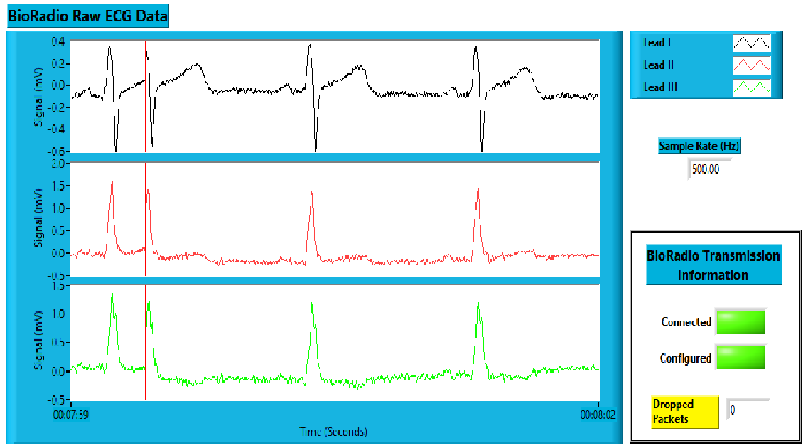

**Figure 1** - Raw ECG Data Sitting

As it can been seen above in figure one lead 1 is the best lead to use to show the PQRST trace.

.

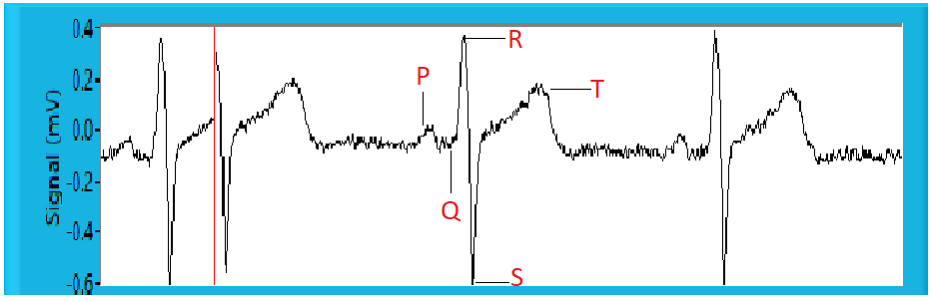

**Figure 2** - Lead 1 ECG Trace with labeled PQRST Complex

The amplitude of the QRS Complex is approximately 0.4 mV. The durations of the segments of the individual heart beat signals do appear to be consistent within the subject.

1. What is the source of the 60Hz noise? Identify and label the 60Hz noise in the frequency plot.

The source of the 60 Hz noise present in the ECG signal is caused by power line interference.

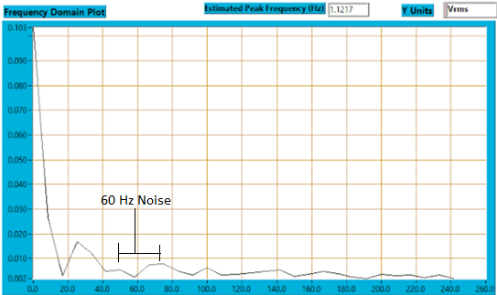

**Figure 3** - 60 Hz noise

1. Discuss the time and frequency signals of the different low pass filter cut off values. On the attached plots, indicate differences. What happens to the time signal with the cut off value decreases? What happens to the frequency signal? Is there an optimal cut off value? What happens when the cut off value is too high? Too low?

When the cut off value decreases in the time domain the signal becomes flat as seen in when comparing Figure 4 which has a cut of value of 40 to Figure 5 which has a cut off value of 1.

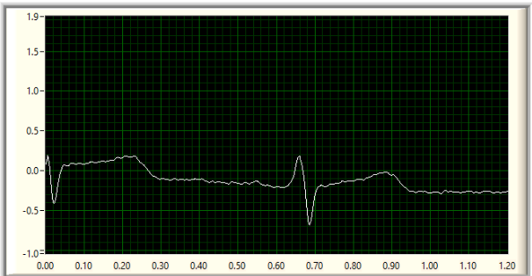

**Figure 4** - Time domain of signal with 40 hz cut off

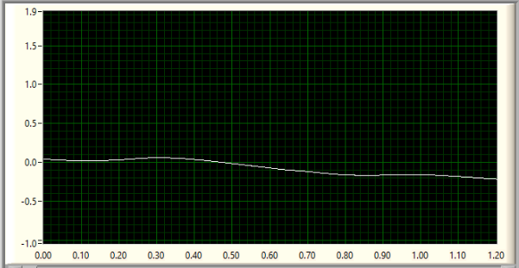

**Figure 5** - Time domain of signal with 1 hz cut off

When speaking of terms of the frequency domain a a decreases in cut off value yields the exclusion of certain frequencies spikes. The comparison between high and low cut off values can be seen below in Figures 5 and 6.

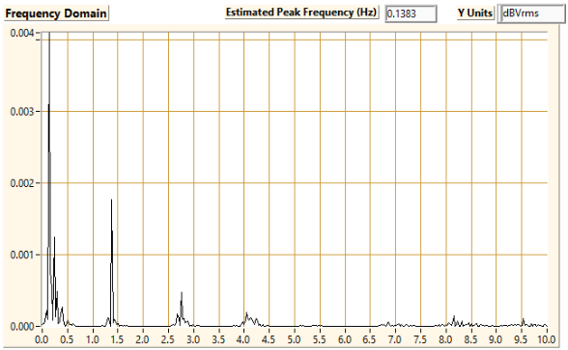

**Figure 5** - Frequency Domain Plot of ECG signal with cut off of 40hz

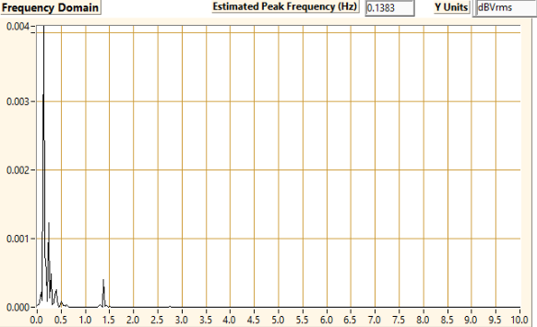

**Figure 6 -** Frequency Domain Plot of ECG signal with cut off of 1 hz

The is an optimal cutoff value that allows the signal to remain intact whilst still removing the introduced noise this value is approximately 20 Hz. when the cutoff value is too high , there is too much noise present within the signal. When the cutoff is to low portions of the signal are filtered out.

**3.0 - Signal Artefact**

1. Look at each lead. Does the ECG Data look different? Why? Does the Spectral Analysis look different? Why or why not?

The ECG data does vary between each of the lead. A graph of the three different lead can be seen below in figure 7. 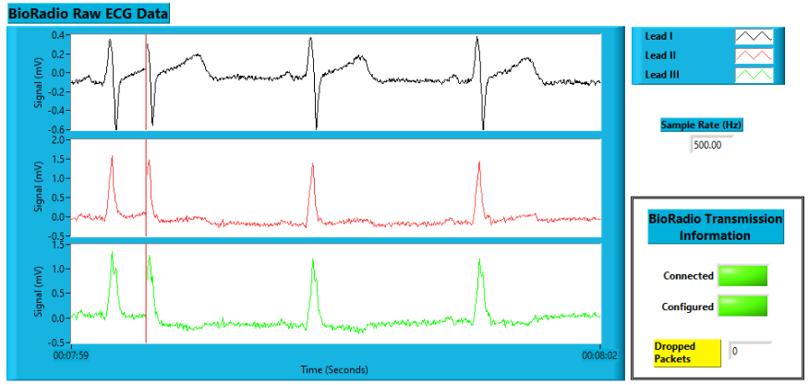

**Figure 7** - Raw ECG Data

It vary because lead 1 is reading the entirety of the signal whist leads 2 and 3 are reading R wave and S wave activity. The spectral data shown in figure 8 below does not look different as it is taken from all the leads.

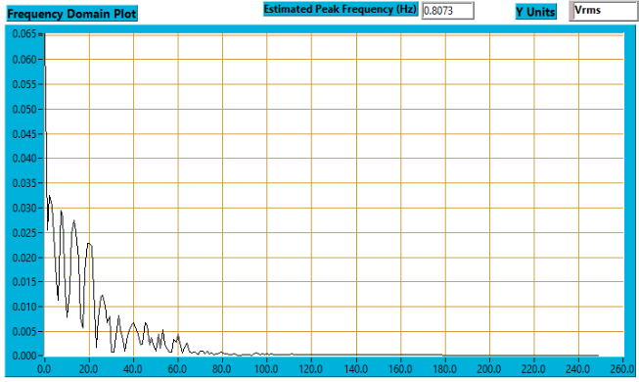

**Figure 8** - Spectral data of ECG data

1. Did you notice motion artifact on all leads? Why did each lead have motion artefact (or not)?

Motion artifacts only occured when the subject was waving. The motion artifacts are seen most clearly on leads 1 and 2 as seen below in Figure 8. But they do appear on all the leads this is because the motion of hand waving causes movement throughout the entire of the body which cause motion artifacts in the ECG signal.

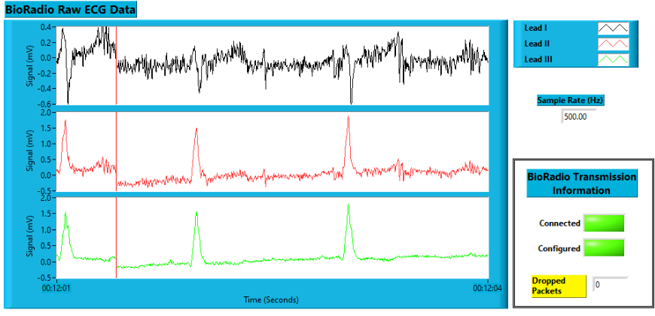

**Figure 9** - Raw ECG data with motion artifacts

**4.0 - Recovery after Exercise**

1. (Max. 100 words) Plot the first 5 heartbeats and the last 5 heart beats of lead I in separate figures, with Matlab. Measure the average R-R distance and calculate the heart rate for both figures. Is there a difference between your two heart rate values? Why?

Based on the calculations the average R-R interval for the first 5 heart beats was 330 units, where the last 5 heartbeats were 360 units. In order to convert this value into seconds, one must divide by the sampling rate (500Hz), yielding the first 5 heartbeats to give an average R-R interval of 0.66 seconds while the last 5 were averaged at 0.72 seconds. This was most likely due to the fact that over the relaxation period, the heart rate begins to slow and returns to normal as more oxygenated blood enters the body. That is why the first 5 heartbeats have a shorter time between beats than the last 5 heartbeats, the body no longer needed as much oxygenated blood because the subject stopped exercising.

1. (Max. 100 words) Compare the PQRST shape in the first and last 5 seconds. Are the shapes compressed? Is the firing rate increased? Explain why

As seen in Figures 16 and 17 below, the first 5 heartbeats reach a peak voltage of 0.3445 mV whereas the last 5 heartbeats reach a peak voltage of 0.3281 mV. This means the shapes compressed for Figure 17 which is the last 5 heartbeats. The firing rate did increase, since the R-R interval time increased when the subject had just completed the exercise versus when the subject had been resting for close to a minute. The firing rate increased because blood is now required to have more oxygen in it since the subject began to exercise and is using more oxygen, so the more times it fires the more blood can enter the system. The shapes compressed in Figure 17 because at the beginning of the exercise, the body needed more oxygen to continue exercising, so stronger contractions of the muscles meant more blood to be cycled through the system, a stronger contraction reads as a larger voltage on the ECG.

**5.0 - Signal Artifact**

1. (Max. 100 words) What are the sources of noise in this lab? Are they low or high frequency? How can you remove/reduce them? You may support your answer by showing some of the graphs recorded during the lab.

Sources of noise in the lab include the 60 Hz power interference noise, since our power sources are set to 60 Hz, that signal showed up in our graphs, because we were analyzing data around that frequency. Additive White Gaussian noise was another source of noise added to the system. These noises are of a higher frequency than what we were analyzing in the lab and therefore with a low pass filter, we can remove them without skewing any of our data. This can be seen by comparing Figure 10 and Figure 11, Figure 11 is significantly less noisy and this is because most of the noise occurred at a frequency higher than 55 Hz.

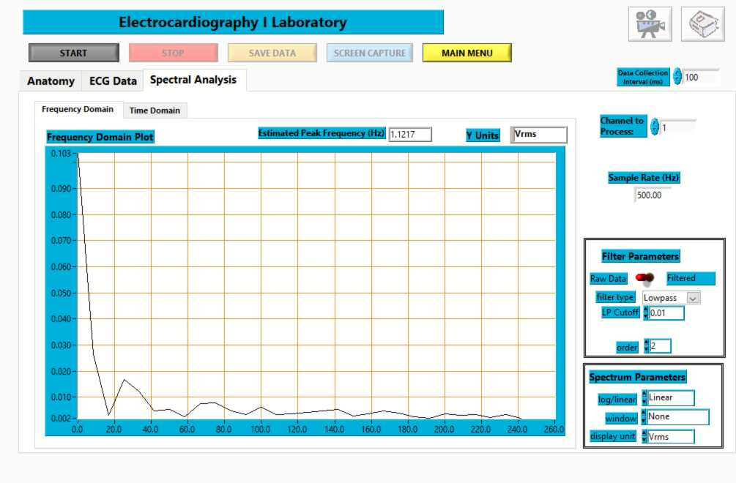

**Figure 10** - Unfiltered Standing Data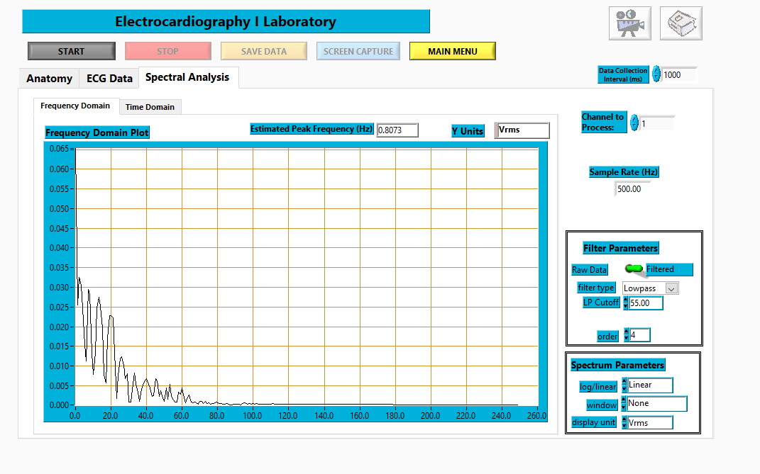

**Figure 11** - Filtered (55 Hz) Standing Data

1. (Max. 50 words) Does your signal ECG have a DC component? What is the source of the DC component? How can you remove it?

There was a DC component in the ECG signal. This DC component came from electrodes attached to the skin as well as powerline interference. In order to remove this DC offset, the use of an instrumentation amplifier will suffice. The instrumentation amplifier uses a high CMMR to have a high gain and to offset the voltage level to something more suitable for the experiment.

**6.0- Appendix**



**Figure 12 -** Frequency spectrum of the ECG data



**Figure 13 -** Raw ECG data

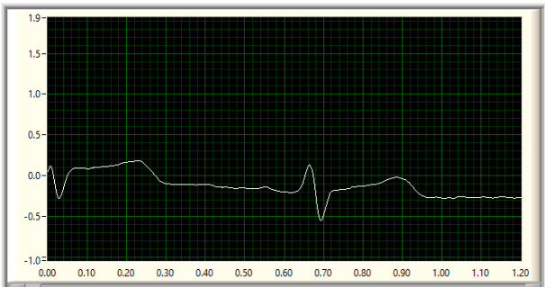

**Figure 14** - ECG data with 20 Hz lowpass filter

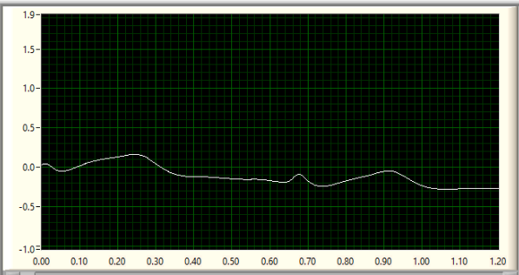

**Figure 15**- ECG data with 5 Hz lowpass filter

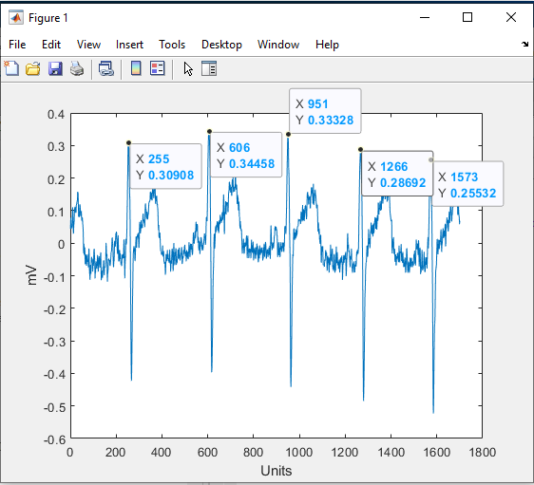

**Figure 16** - First 5 heartbeats of lead I

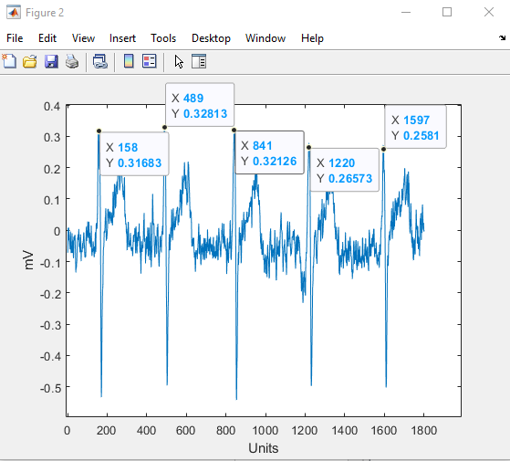

**Figure 17** - Last 5 heartbeats of lead I